https://www.linkedin.com/in/vlad-ionescu-7bb867102/?originalSubdomain=ro

<https://scholar.google.ro/citations?user=iUuFgp0AAAAJ&hl=en>

<https://scoalaspor.ro/tutori/vlad-ionescu/>

<https://www.researchgate.net/profile/Vlad-Sebastian-Ionescu>

<https://www.researchgate.net/scientific-contributions/Vlad-Sebastian-Ionescu-2113843386>

<https://scholar.google.com/citations?user=iUuFgp0AAAAJ&hl=ro>

https://metno.github.io/weamyl-website-ro/dissemination/

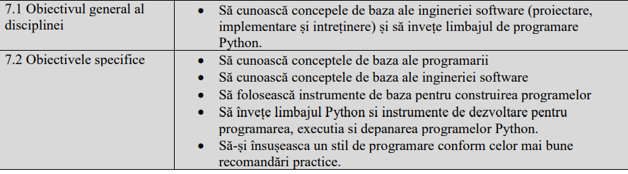

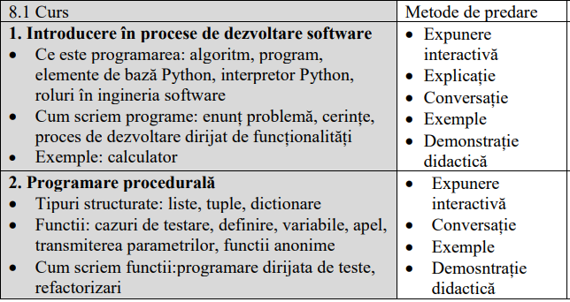

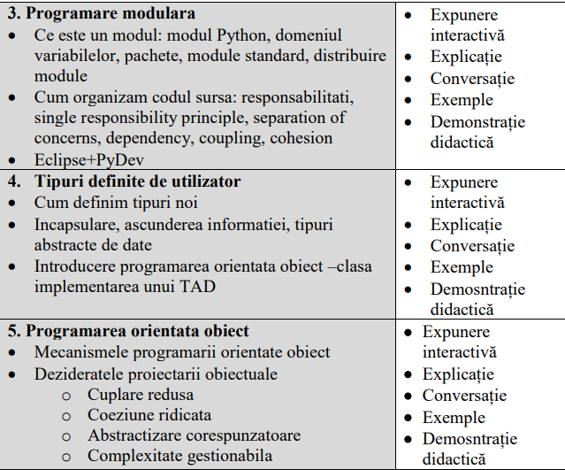

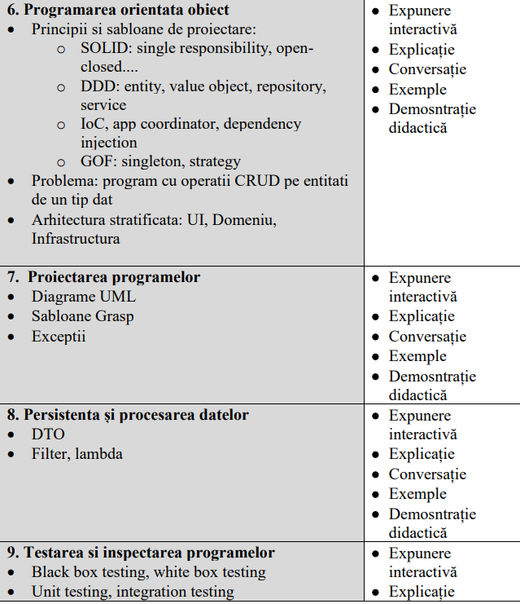

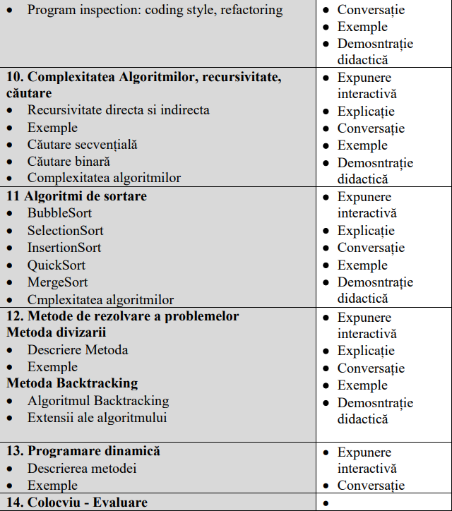

Bibliografie https://www.cs.ubbcluj.ro/files/curricula/2022/syllabus/MIR_sem1_MLR5005_ro_ivlad_2022_7148.pdf

1. Kent Beck. Test Driven Development: By Example. Addison-Wesley Longman, 2002. See also Testdriven development. http://en.wikipedia.org/wiki/Test-driven_development

2. Martin Fowler. Refactoring. Improving the Design of Existing Code. Addison-Wesley, 1999. See

also http://refactoring.com/catalog/index.html

**3. Thomas H. Cormen, Charles E. Leiserson, Ronald L. Rivest, Clifford Stein. Introduction to Algorithms 3rd**

**ed., 2009.**

**4. Craig Larman. Applying UML and Patterns. An Introduction to Object Oriented Analysis and Design, 2004.**

5. The Python language reference. http://docs.python.org/py3k/reference/index.html

6. The Python standard library. http://docs.python.org/py3k/library/index.html

The Python tutorial. http://docs.python.org/tutorial/index.html

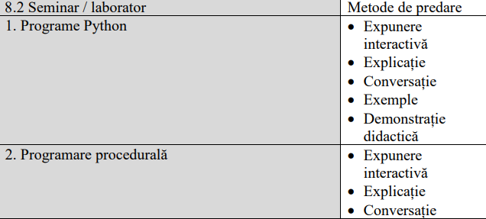

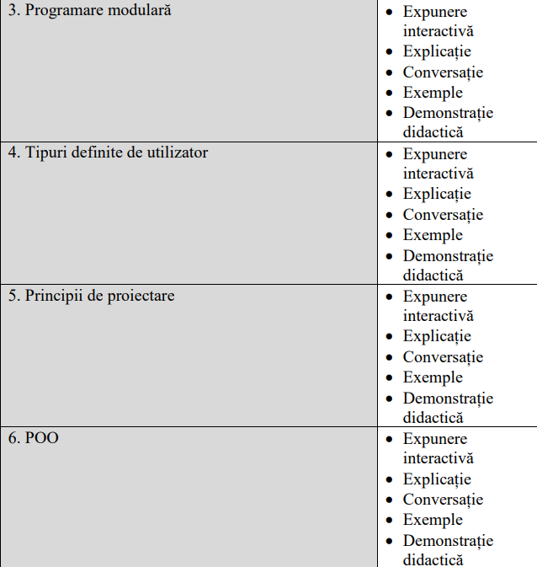

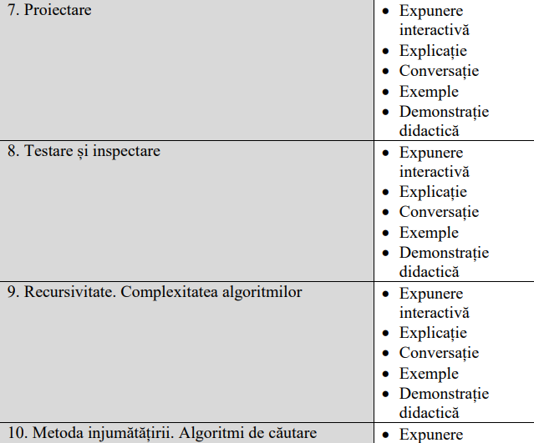

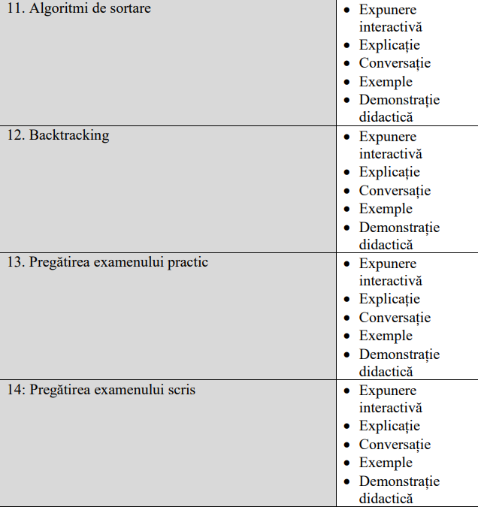

Bibliografie

1. Kent Beck.Test Driven Development: By Example. Addison-Wesley Longman, 2002. See also Testdriven development. http://en.wikipedia.org/wiki/Test-driven_development

2. Martin Fowler. Refactoring. Improving the Design of Existing Code. Addison-Wesley, 1999. See

also http://refactoring.com/catalog/index.html

3. Frentiu, M., H.F. Pop, Serban G., Programming Fundamentals, Cluj University Press, 2006

4. The Python language reference. http://docs.python.org/py3k/reference/index.html

5. The Python standard library. http://docs.python.org/py3k/library/index.html

The Python tutorial. http://docs.python.org/tutorial/index.html